Product Review and Rating Management System
Project Title: E-Commerce Order Management Database System

Project Title : E-Commerce Order Management Database System
Student Name : Yakesh J
Register Number : C4S38024
Department : B.Sc Artificial Intelligence
Course : Artificial intelligence (AI)
Academic Year : 2024 – 2027

1. Create Database
CREATE DATABASE ProductReviewDB;
USE ProductReviewDB;
2. Create Product Table
CREATE TABLE Product (
product_id INT PRIMARY KEY AUTO_INCREMENT,
product_name VARCHAR(100) NOT NULL,
price DECIMAL(10,2)
);
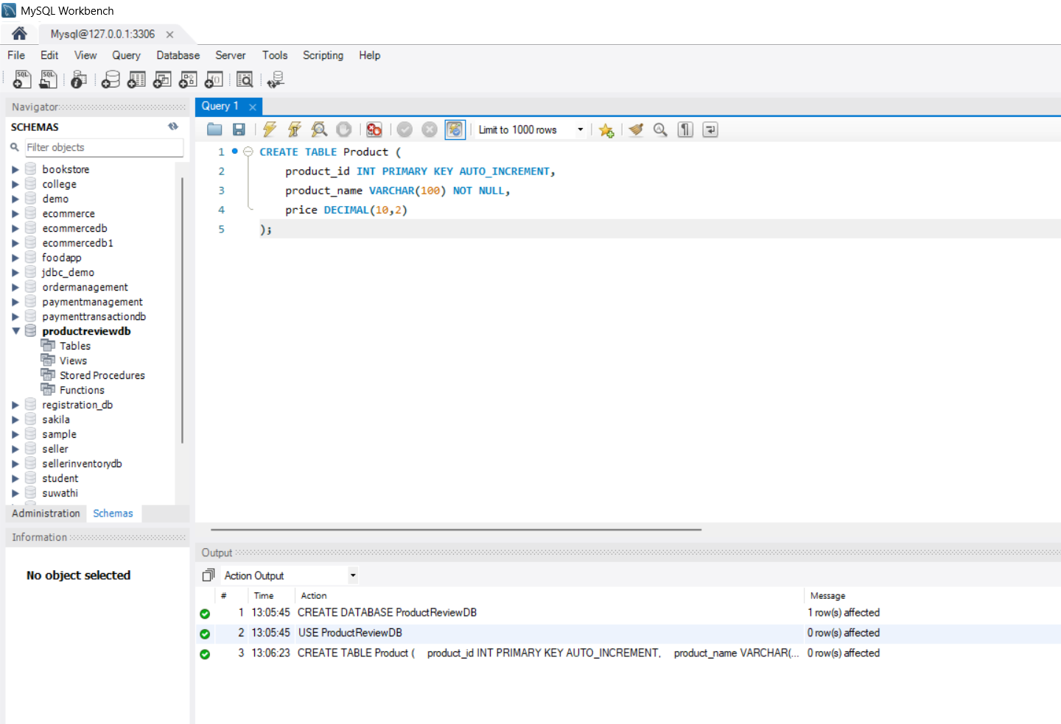
3. Create Review Table
CREATE TABLE Review (
review_id INT PRIMARY KEY AUTO_INCREMENT,
product_id INT,
customer_name VARCHAR(100),
review_text VARCHAR(500),
review_date DATE,
FOREIGN KEY (product_id) REFERENCES Product(product_id)
);
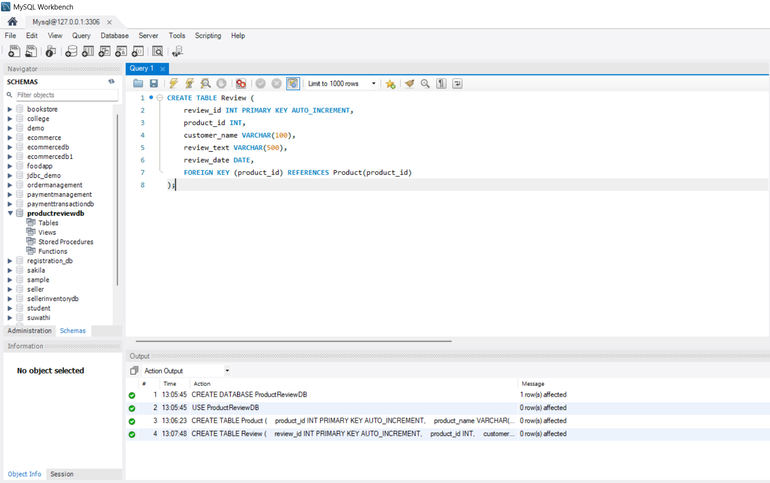
4. Create Rating Table
CREATE TABLE Rating (
rating_id INT PRIMARY KEY AUTO_INCREMENT,
product_id INT,
customer_name VARCHAR(100),
rating INT CHECK (rating BETWEEN 1 AND 5),
rating_date DATE,
FOREIGN KEY (product_id) REFERENCES Product(product_id)
);
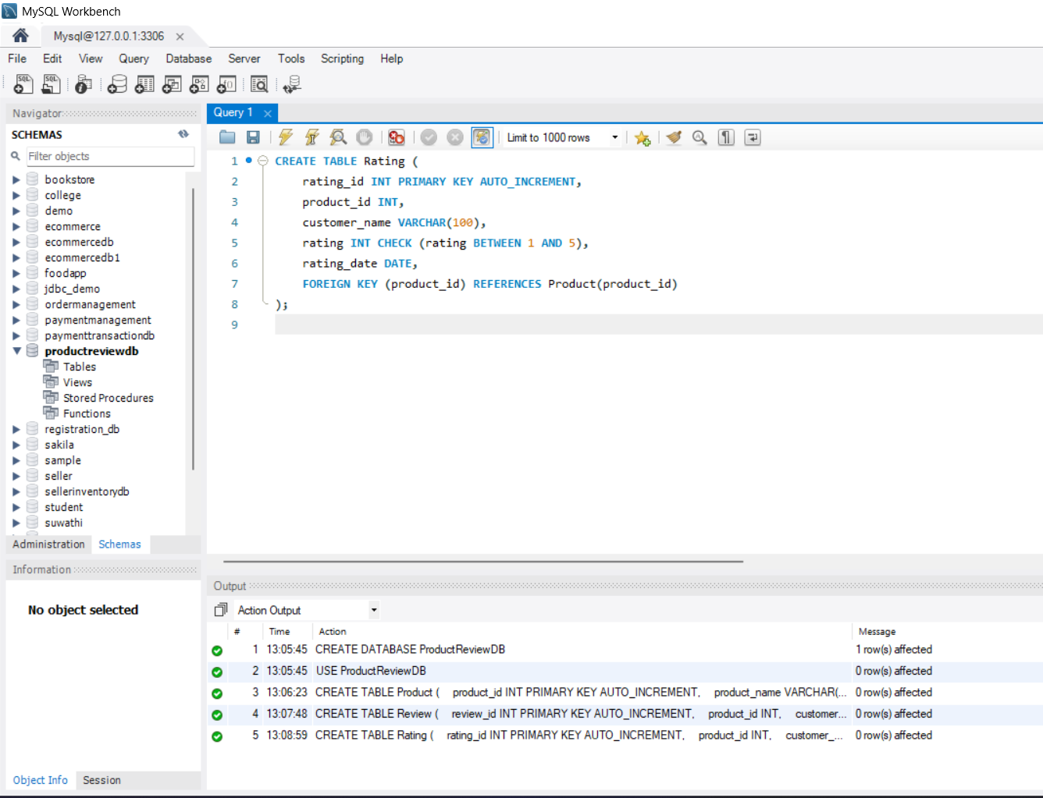
5. Insert Product Details
INSERT INTO Product (product_name, price)
VALUES
('Laptop', 55000),
('Smartphone', 25000),
('Headphones', 3000),
('Smart Watch', 5000);
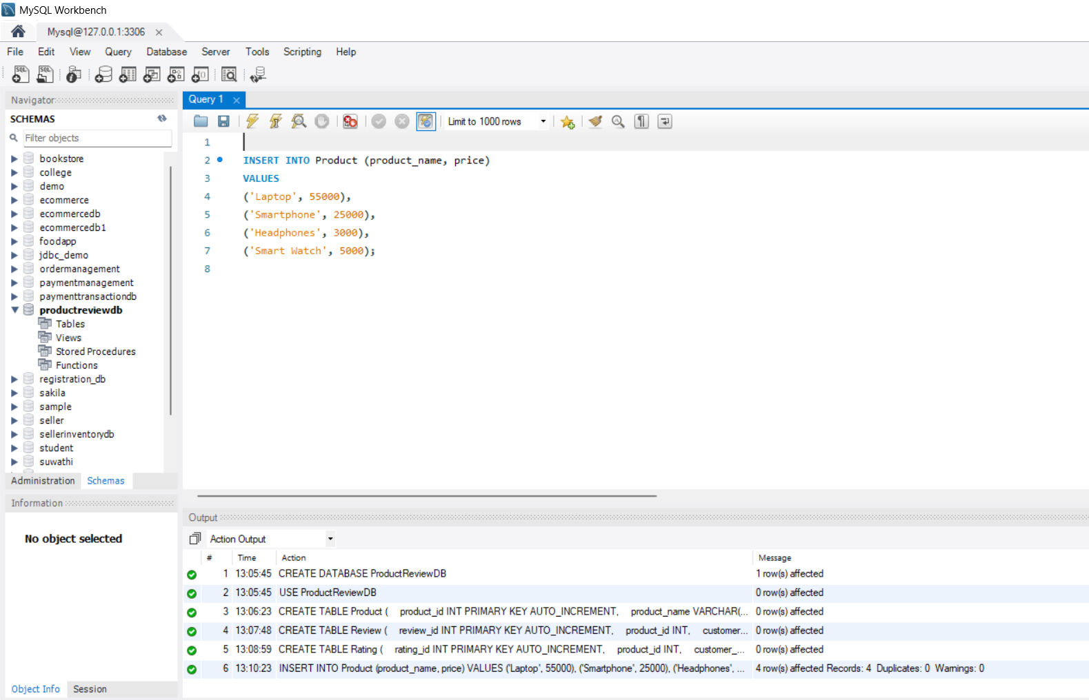
6. Store Customer Reviews
INSERT INTO Review
(product_id, customer_name, review_text, review_date)
VALUES
(1, 'Arun', 'Very good laptop', '2026-08-01'),
(2, 'Kumar', 'Good smartphone', '2026-08-02'),
(3, 'Ravi', 'Excellent sound quality', '2026-08-03'),
(4, 'Anu', 'Useful and stylish watch', '2026-08-04');
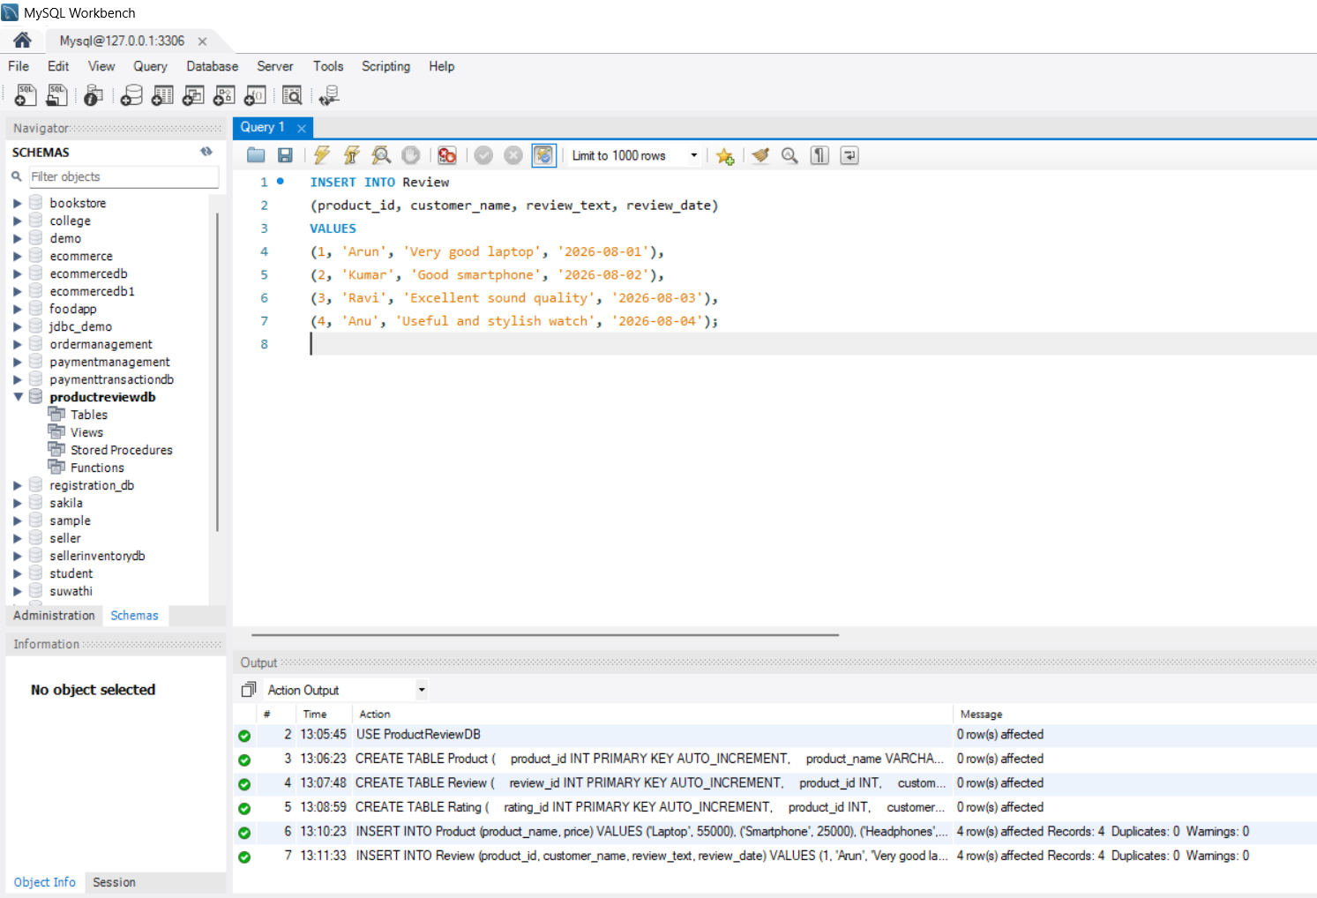
7. Store Customer Ratings
INSERT INTO Rating
(product_id, customer_name, rating, rating_date)
VALUES
(1, 'Arun', 5, '2026-08-01'),
(1, 'Priya', 4, '2026-08-02'),
(2, 'Kumar', 4, '2026-08-02'),
(2, 'Anu', 5, '2026-08-03'),
(3, 'Ravi', 5, '2026-08-03'),
(4, 'Anu', 4, '2026-08-04');
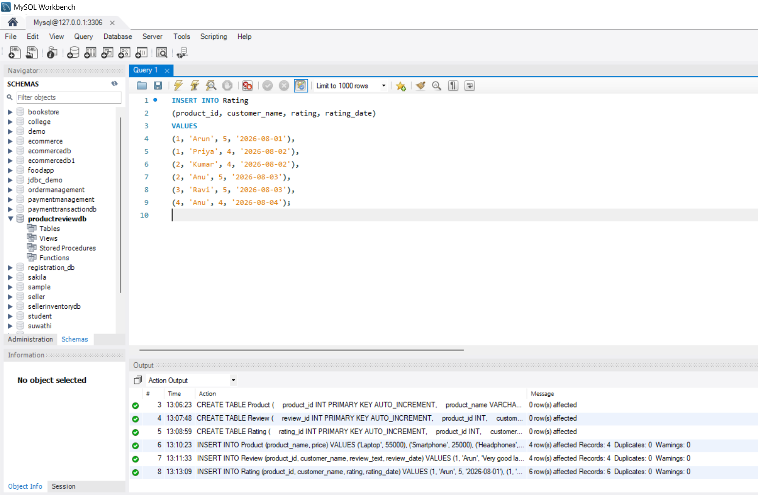
8. Retrieve Product Review Details
SELECT
p.product_name,
r.customer_name,
r.review_text,
r.review_date
FROM Product p
JOIN Review r
ON p.product_id = r.product_id;
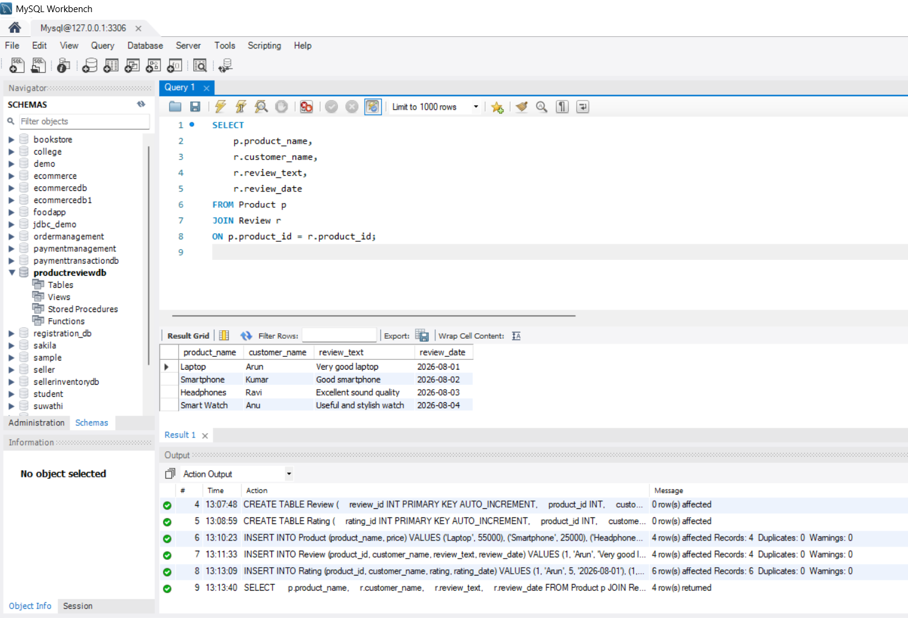
9. Calculate Average Product Rating
SELECT
p.product_name,
AVG(r.rating) AS average_rating
FROM Product p
JOIN Rating r
ON p.product_id = r.product_id
GROUP BY p.product_id, p.product_name;
10. Identify Highly Rated Products
For products with an average rating of 4 or above:
SELECT
p.product_name,
AVG(r.rating) AS average_rating
FROM Product p
JOIN Rating r
ON p.product_id = r.product_id
GROUP BY p.product_id, p.product_name
HAVING AVG(r.rating) >= 4;
